Geometry: Unit 1, Lesson 3
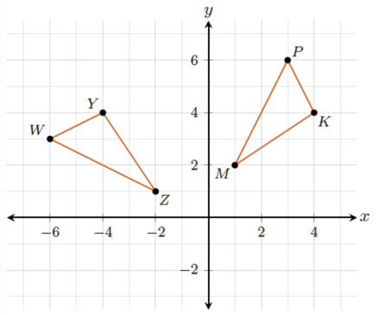
- A transformation $∆WYZ$ is mapped onto $∆PKM$ on the coordinate plane. What vertex from triangle WYZ would map onto vertex K on triangle PKM?

Vertex Y

- What is preserved when a transformation is an isometry?

Angle Measure and Distance

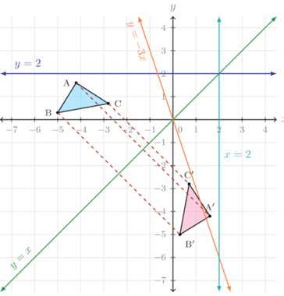
- Triangle $ABC$ is reflected across a line to create Triangle $A'B'C'$. What is the line of reflection?

$$y=x$$

